**Experiment 2. Half adder and full adder**

Date: 04/06/21

**AIM**

b) Development of Verilog modules for full adder(dataflow level)

**VERILOG CODE**

**Data flow level**

module fulladder(

input wire a,b,cin,

output wire s,cout);

assign s = a^b^cin;

assign cout = (cin&(a^b))|(a&b);

endmodule

**Testbench**

// Code your testbench here

// or browse Examples

`timescale 1ns/1ps

module test_full;

reg t_a,t_b,t_cin;

wire t_s,t_cout;

fulladder uut(.a(t_a),.b(t_b),.cin(t_cin),.s(t_s),.cout(t_cout));

initial

begin

$dumpvars(1,test_full);

t_a=1'b0;

t_b=1'b0;

t_cin=1'b0;

#10;

t_a=1'b0;

t_b=1'b0;

t_cin=1'b1;

#10;

t_a=1'b0;

t_b=1'b1;

t_cin=1'b0;

#10;

t_a=1'b0;

t_b=1'b1;

t_cin=1'b1;

#10;

t_a=1'b1;

t_b=1'b0;

t_cin=1'b0;

#10;

t_a=1'b1;

t_b=1'b0;

t_cin=1'b1;

#10;

t_a=1'b1;

t_b=1'b1;

t_cin=1'b0;

#10;

t_a=1'b1;

t_b=1'b1;

t_cin=1'b1;

#10;

$stop;

end

endmodule

**Output**

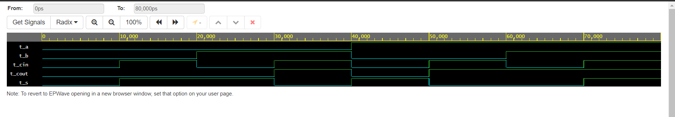

**Experiment 3: Design of code converters**

**AIM**

Design and simulate the HDL code for(1/06/2021)  
(a) 4- bit binary to gray code converter

**VERILOG CODE**

**Gate level**

module bintogray(

input [3:0]b,

output [3:0]g);

xor x1(g[0],b[0],b[1]);

xor x2(g[1],b[1],b[2]);

xor x3(g[2],b[2],b[3]);

buf b1(g[3],b[3]);

endmodule

**Testbench**

// Code your testbench here

// or browse Examples

`timescale 1ns/1ps

module test_bintogray;

reg [3:0] t_b;

wire [3:0] t_g;

bintogray uut(.b(t_b),.g(t_g));

initial

begin

$dumpvars(1,test_bintogray);

t_b = 4'b1100;

#10;

t_b = 4'b1010;

#10;

t_b = 4'b0011;

#10;

t_b = 4'b1111;

#10;

$stop;

end

endmodule

**Output**

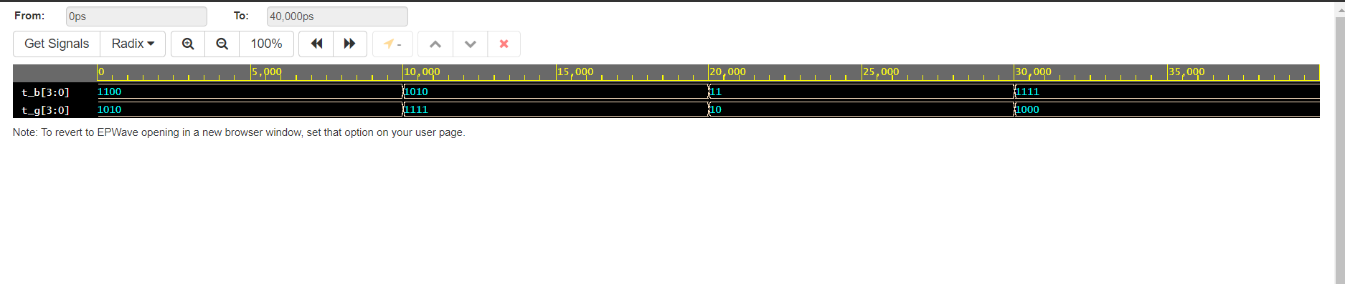

(b) 4- bit gray to binary code converter

**VERILOG CODE**

**Gate level**

// Code your design here

module graytobin(

input [3:0]g,

output [3:0]b);

buf b1(b[3],g[3]);

xor x1(b[2],b[3],g[2]);

xor x2(b[1],b[2],g[1]);

xor x3(b[0],b[1],g[0]);

endmodule

**Testbench**

// Code your testbench here

// or browse Examples

`timescale 1ns/1ps

module test_graytobin;

reg [3:0] t_g;

wire [3:0] t_b;

graytobin uut(.g(t_g),.b(t_b));

initial

begin

$dumpvars(1,test_graytobin);

t_g = 4'b1100;

#10;

t_g = 4'b1001;

#10;

t_g = 4'b0101;

#10;

t_g = 4'b1101;

#10;

$stop;

end

endmodule

**Output**

